A Circular Plastics Economy Strategy for India
27 October 2020
1330 to 1430 hours (UTC + 3); 1600 to 1700 hours (IST)
Venue: Virtual
Objective
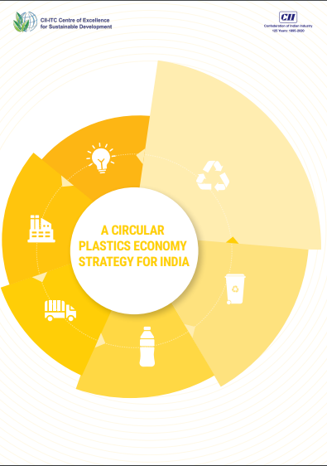
In the event a new report launched by the Confederation of Indian Industry on the strategy for managing plastics in India based on circular economy principles will be the subject of discussion.
Speakers
The panellists will include representatives from industry, academia, research organizations and civil society.
Target Audience
The event will be of interest to industry, academia, non-profit organizations, research institutions, policy-makers, charities/philanthropies, bilateral and multilateral organizations, waste management professionals working with/in Indi
To Register
Please follow this link to register for the event. For queries, email shourjomay.c@cii.in
Agenda (tentative)
Time
UTC + 3 | IST
1330 to 1340 hours | 1600 to 1610 hours | Introduction  Seema Arora, Deputy Director General, Confederation of Indian Industry
1340 to 1400 hours | 1610 to 1630 hours | The Circular Plastics Economy Strategy for India  Dr Nandini Kumar, Consultant, Confederation of Indian Industry
1400 to 1430 hours | 1630 to 1700 hours | Panel discussion  Moderated by CII  - Industry representative (TBC)  - Industry representative (TBC)  - International body representative (TBC)  - Civil society representative (TBC)
1430 to 1450 hours | 1700 to 1720 hours | Questions and answers  Moderated by CII
1450 t0 1500 hours | 1720 to 1730 hours | Closing remarks  CII

